Guideline for ‘Taekwondo Day’

Hello, everyone!
Thank you for participating in “Taekwondo Day” organized by the SWCIC.
This is a guideline for the program, and I hope to all of you enjoy this event!

<Itinerary>
Time | Contents | Place
13:00 | Gathering & Orientation | Suwon Center for International Cooperation
13:00-14:00 | Move to MTA I-Star Taekwondo center | MTA I Star Taekwondo Center
14:00-16:00 | Experiencing Taekwondo | MTA I Star Taekwondo Center
16:00-17:00 | Return to the SWCIC

NOTICE: Please tick on the application form where you want to be picked up.
Option 1> Those who want to go to the Taekwondo Center with us, please come to the SWCIC by 13:00.
Option 2> Those who want to come to the Taekwondo center directly, you can meet us at the Taekwondo Center at 14:00. Although the center is located close to Sungkyunkwan Uni, you still need to take a bus. The bus journey will take about 20 min.
Punctuality will be highly appreciated!

<Contact Point>
Email : scvakorea@gmail.com Telephone: 031 226 3448
Please refer to the map on the next page how to find the SWCIC or the Taekwondo Center.
Option 1> Suwon Center for International Cooperation: 178, Ingye-ro, Paldal-gu, Suwon-si 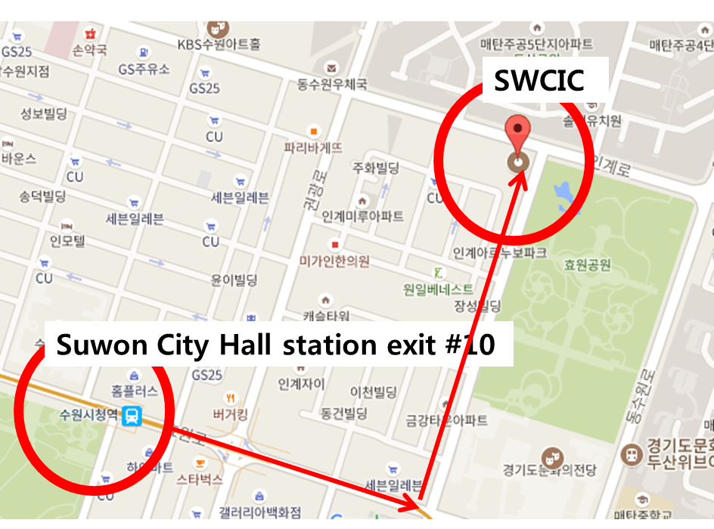
Option 2> Taekwondo Center: Geumgok-ro 102beon-gil, Gwonseon-gu, Suwon-si

